Primary and secondary metabolites
Chemicals of the medicinal plants
Plants produce very complex and diverse chemical substances. Some of them have a strong pharmacological effect (active substances) and determine the therapeutic value of raw materials, while others express the therapeutic effect does not have a (related substances), but their presence should be considered during the processing of raw materials (drying, storage, preparation of herbal medicines).
Biologically active substances are the substances which affect the biological processes in human. In most cases they are compounds of secondary cycle. Some biologically active substances (for example, oxycinnamon acids) are not acccumulates in plants, after formation they are spent for other biosynthetic purposes. Other substances (alkaloids, volatile oils, tannins and oth.) conversely have a tendency for accumulation in plants.
The particular group of substances of medicinal plants has the therapeutic effect, it is called pharmacologically active substances. Secondary metabolites and some primary metabolites (vitamins, polysaccharides, lipids) are pharmacologically active substances. One or several complexes of pharmacologically active substances are accumulated in certain parts of medicinal plants, whic are used as a raw material. However in most cases one or several substances are main pharmacologically active substances. For example, the main pharmacologically active substances in belladonna leaf are alkaloids – hyoscyamine (atropine) and scopolamine. Other tropane alkaloids – hygrine, kushygrine, methylpyrrolidin are not pharmacologically active substances. The main pharmacological substances in other words are called active substances. Along with active substances other substances called contaminant are included in medicinal plants. Contaminant substances can be useful and harmful. For example, the active substances of foxglove plant are the cardiac glycosides, but the contaminant substances are saponins. These saponins enhance the solubility and contribute to absorption of cardiac glycosides. Toxalbumin in castor seeds is a harmful contaminant substance. That’s why the fixed oil which is a active substance should be purified from toxalbumin.
Ballast substances are pharmacologically neutral substances, which are present in plants and have no therapeutic action. For example, starch is a ballast substance in marshmallow root, gums, cellulose and pectin – in senna leaf. However, there is no dividing line between ballast and pharmacologically active substances. The same group of substances in various plants can play role either ballast substances or pharmacologically active substances. For example the fixed oils are the ballast substancs of fennel fruits, but they are one of the main active substance of hemp seeds.
Medicinal plants have a diversity of chemical composition and they contains dozens of organic substances as biologically active, inert as ballast. In nature there is no completely useless plant for human body. It applies to certain species of medicinal plants according to the type of biologically active substances, amount and combined action of certain pharmacological substances. There are many plants which are not medicinal, but they are used for therapeutic purposes in traditional medicine and as food.
Main criterion of activity of biologically active substances is ability to influence on the processes occured in organism. Among many substances containing in plants it is important to distinguish one or several substances which determine the pharmacological effects, which constitute the therapeutic value of the plant - these are the active substances. Other biologically active substances of plants besides the active substances are called excipients. They can be useful, and has a positive impact on organism (vitamins, organic acids, microelements and oth.), increase the efficiency of main active compounds. Contaminant substances can be harmful and cause the undesirable effects. There are ballast or inert substance. The presence of these substances in dosage form does not reflect on the pharmacological action of main substances and excipients. This division is conditional.
The spectra of biological activity of medicinal plants is determined by the presence of active substances of various chemical classes and groups. The amount of the substances present in medicinal plants can vary from dozens to hundreds. All of this is conditioned by the domination of one or other pharmacological effect (effects) of certain plant or meaningful choice in the prescription for therapeutic or preventive purposes. Pharmacological effect of medicinal plant is formed according to high composition of the substances and it is prescribed for therapeutic or preventive purposes. In addition, the therapeutic properties of medicinal plants depend on the presence of some substances with unique pharmacological action (cardiac glycosides, alkaloids, steroid compounds and oth.). According to the character and activity degree of these substances the medicinal plants are divided on superpotent and poisonous. These medicinal plants are rarely used in traditional medicine.

Natural products chemistry
Organic compounds of medicinal plants are divided into two groups:
The products of primary exchange or primary metabolites;
The products of secondary exchange or secondary metabolites.
The primary metabolites are proteins, carbohydrates (polysaccharides), lipids, enzymes, vitmains and trace elements.
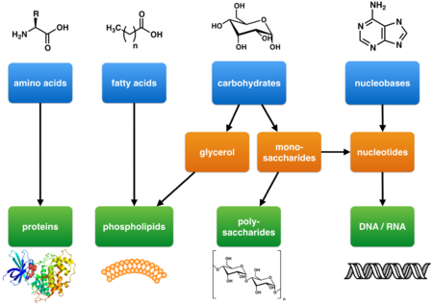
Primary metabolites as defined by Kossel are components of basic metabolic pathways that are required for life. They are associated with essential cellular functions such as nutrient assimilation, energy production, and growth/development. They have a wide species distribution that span many phyla and frequently more than one kingdom. Primary metabolites include carbohydrates, lipids, amino acids, and nucleic acids which are the basic building blocks of life.
Primary metabolites that are involved with energy production include respiratory and photosynthetic enzymes. Enzymes in turn are composed of amino acids and often non-peptidic cofactors that are essential for enzyme function. The basic structure of cells and of organisms are also composed of primary metabolites. These include cell membranes (e.g. phospholipids), cell walls (e.g. peptidoglycan, chitin), and cytoskeletons (proteins).
Primary metabolite enzymatic cofactors include members of the vitamin B family. Vitamin B1as thiamine diphosphate is a coenzyme for pyruvate dehydrogenase, 2-oxoglutarate dehydrogenase, and transketolase which are all involved in carbohydrate metabolism. Vitamin B2 (riboflavin) is a constituent of FMN and FAD which are necessary for many redox reactions. Vitamin B3 (nicotinic acid or niacin), synthesized from tryptophan is a component of the coenzymes NAD+ and NADP+ which in turn are required for electron transport in the Krebs cycle, oxidative phosphorylation, as well as many other redox reactions. Vitamin B5(pantothenic acid) is a constituent of coenzyme A, a basic component of carbohydrate and amino acid metabolism as well as the biosynthesis of fatty acids and polyketides. Vitamin B6(pyridoxol, pyridoxal, and pyridoxamine) as pyridoxal 5′-phosphate is a cofactor for many enzymes especially transaminases involve in amino acid metabolism. Vitamin B12(cobalamins) contain a corrin ring similar in structure to porphyrin and is an essential coenzyme for the catabolism of fatty acids as well for the biosynthesis of methionine.
DNA and RNA which store and transmit genetic information are composed of nucleic acid primary metabolites.
To carbohydrates include cellulose, sugar, starch, inulin, etc. Cellulose is the skeleton of the plant, it does not dissolve either in water or organic solvents, so after extracting active ingredients in the preparation of drugs is in the garbage.
Fiber is part of the integumentary tissues. In the epidermis fiber combined with wax-like substance - Kutin. Cork fabric - a fiber impregnated with suberin. Lignified tissue - tissue, impregnated with lignin, - is wood vessels and tracheids, and is found in all plant organs, most of all - in wood barrels. Woody and mechanical fabric - fiber and stony cell. Pharmacists interested in the presence and amount of lignified tissue in the selection of a tool for grinding raw materials.
Mucus and gums are formed by mucilaginized cell walls and are found in raw materials is not so often. There are some mucous cells in the parenchyma of various organs of plants, found in the epidermis of mucilaginous seeds, but most formed by mucilaginized core or cambium layer of trees and shrubs. Mucous material hygroscopic and when stored in a damp place easily get moldy.
Starch in small quantities is available in all parts of the plant, but the reserve is deposited in the seeds, the roots and rhizomes. Cold water and organic solvents it is not extracted in hot water forms a turbid and viscous colloidal solution, which prevents the filtration. Raw, rich in starch, it should be protected from pests.
Inulin is formed in the composite, which is delayed as a storage material instead of starch. Hydrolysis splits to fructose, in contrast to starch. Easily soluble in water and filtering does not interfere.
Mono-and disaccharides in small amounts are found in almost all parts of the plant, in a stock laid in fruit, roots, stems, grasses and other raw sweet, often under attack pests.
Fatty oil postponed as reserve nutrients in the seeds, fruits, and occasionally in the underground organs. Fatty oil used in medicine. During the processing of raw materials, rich in oil, it is sometimes necessary to remove previously. When storing raw materials, rich in oil, in powdered form, it quickly deteriorates and rancid, pests dangerous for him.
Protein substances in the processing of raw material plays no essential role. Food selection: resin, rubber, gutta-percha - a raw material are ballast and difficult processing. In medicine they are used to extracted from the plant form.
Chemical substances are found in all plant tissues - in the dissolved cell sap or in crystals of calcium oxalate. The combustion of any plant is a small residue of ash, an average of 1-10%. In each of the natural elements of the ash are: N a, K, M g, Ca, Si, P, S. This macro. But, in addition, there are trace elements in plants, the content of which is thousandths of one percent or less. Among the trace elements are found: Co, F e, Cr, C, u, Mn, Mo, N i, A g, A s, Zn and other trace elements accumulation in plants depends on soil, and it is usually selective: different species of plants sucking the different trace elements . Some trace elements have therapeutic value. Found that plants that accumulate higher amount of manganese, have wound-healing effect.
We traced some regularity between the ability of plants to synthesize a certain group of physiologically active substances and selective absorption properties of the soil of certain trace elements. For example, alkaline plant - belladonna and poppy - selectively accumulate cobalt, copper and manganese; crap, an herb that serves as a source of obtaining flavonoid rutin, selectively accumulates copper and chromium. Types of digitalis, cardiac glycosides wealthy, accumulate

Macroelemetns are included in the substances, that carry out the essential processes. For example, phosphorus is a component of ATP, which is the instrumental in the storage of energy, which is released when ATP is converted into ATP and AMP. Fe, Ca and Mo are involved in formation of several enzymes, Zn – hormones, Mg –is a component of chlorophyll. Potassium is essential element for water accumulation and storage in cytoplasm.
Microelements play a big role in plant organism. For example, element Cu is involved in the biosynthesis of the phenolic compounds, vitamins, proteins and pigments in plants.
Molybdenum influences the synthesis and distribution of carbohydrates in plant organism, creation of chlorophyll and ascorbic acid and biosynthesis of aminoacids.
Cobalt is involved in several important biochemical processes, occuring in plant and therefore it increases the activity of certain enzymes.
Nickel influences the activity of enzymes which carry out the oxidation-reduction processes (for example, nitratreductase, phenoloxidase and oth.).
Wolfram stimulates the photosynthesis process in plants, with molibdenum it enhances the nutrition of poaceae, legumes and some perennial herbaceous plant by nitrogen. Microelements are involved in the biosynthesis of biologically active substancs of medicinal plants – cardiac glycosides, saponins, flavonoids, coumarins, tannins, vitamins, alkaloids, terpenoids, polysaccharides and oth.
Along with biologically active substances mineral substances can influence the pharmacological effect of plants. In present time the use of microelements are important for the treatment of circulatory system, malignant tumour and oth. serious illnesses. It was also found, that microelements with biologically active substances in plant medicines have a more effective eeffect.

The secondary metabolites
Along with primary metabolites the secondary metabolites are synthesized in plants. They include organic acids, alkaloids, tannins, cooumarins, flavonoids, volatile oils, saponins, simple phenolic compounds and oth. 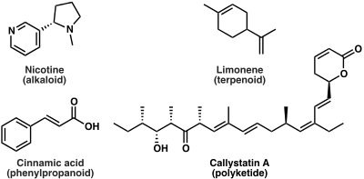

Secondary metabolites in contrast to primary metabolites are dispensable and not absolutely required for survival. Furthermore, secondary metabolites typically have a narrow species distribution.
Secondary metabolites have a broad range of functions. These include pheromones that act as social signaling molecules with other individuals of the same species, communication molecules that attract and activate symbiotic organisms, agents that solubilize and transport nutrients (siderophores etc.), and competitive weapons (repellants, venoms, toxins etc.) that are used against competitors, prey, and predators. For many other secondary metabolites, the function is unknown. One hypothesis is that they confer a competitive advantage to the organism that produces them. An alternative view is that, in analogy to the immune system, these secondary metabolites have no specific function, but having the machinery in place to produce these diverse chemical structures is important and a few secondary metabolites are therefore produced and selected for.
Plants are capable of producing and synthesizing diverse groups of organic compounds and are divided into two major groups: primary and secondary metabolites. Secondary metabolites are metabolic intermediates or products which are not essential to growth and life of the producing plants but rather required for interaction of plants with their environment and produced in response to stress. Plant secondary metabolites can be divided into four major classes: terpenes, phenolics, glycosides and alkaloids.
- Terpenes constitute a large class of natural products which are composed from isoprene units. Terpenes are only hydrocarbons and terpenoids are oxygenated hydrocarbons. The general molecular formula of terpenes are multiple of (C₅H₈)_{n ,} where 'n' is number of linked isoprene units. Hence, terpenes are also termed as isoprenoid compounds. Classification is based on the number of isoprene units presentin their structure.

Number of isoprene units | Name | Carbon atoms
2 | Monoterpene | C₁₀
3 | Sesquiterpenes | C₁₅
4 | Diterpene | C₂₀
6 | Triterpene | C₃₀
8 | Tetraterpene | C₄₀
More than 8 | Polyterpene
Terpenes and terpenoids of many kinds are found in resinous plants such as the conifers. They are strongly aromatic and serve to repel herbivores. Their scent makes them useful in essential oils, whether for perfumes such as rose and lavender, or for aromatherapy. Some have had medicinal uses: thymol is an antiseptic and was once used as a vermifuge(anti-worm medicine).
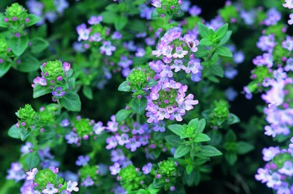
The essential oil of common thyme (Thymus vulgaris), contains the monoterpene thymol, an antiseptic and antifungal.
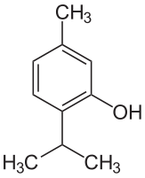

Thymol is one of many terpenesf ound in plants.

- A phenolic is a chemical compound characterized by the presence of aromatic ring structure bearing one or more hydroxyl groups. Phenolics are most abundant secondary metabolites of plants ranging from simple molecules such as phenolic acid to highly polymerized substances such as tannins. Classes of phenolics have been characterized on the basis of their basic skeleton.

No. of carbon atoms | Basic skeleton | Class
6 | C₆ | Simple phenols
7 | C₆ - C₁ | Phenolic acids
8 | C₆ - C₂ | Acetophenone, Phenyle acetic acid
9 | C₆ - C₃ | Phenylepropanoids, hydroxycinnamic acid, coumarins
10 | C₆ - C₄ | Naphthoquinone
13 | C₆ - C₁- C₆ | Xanthone
14 | C₆ - C₂ - C₆ | Stilbene, anthraquinone
15 | C₆ - C₃ - C₆ | Flavonoids, isoflavanoids
18 | (C₆ - C₃ ) ₂ | lignans, neolignans
30 | ( C₆ - C₃ - C₆)₂ | Biflavonoids

Polyphenols
Polyphenols of several classes are widespread in plants. They include the colourful anthocyanins, hormone-mimicking phytoestrogens, and astringent tannins. In Ayurveda, the astringent rind of the pomegranate is used as a medicine, while polyphenol extracts from plant materials such as grape seeds are sold for their potential health benefits They have been continually studied in cell cultures for their different anti-cancer effects.
Plants containing phytoestrogens have been used for centuries to treat gynaecological disorders such as fertility, menstrual, and menopausal problems. Among these plants are Pueraria mirific, kudzu, angelica, fennel, and anise
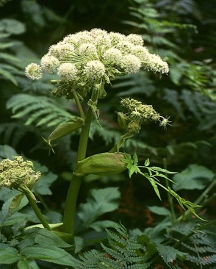
Angelica, containing phytoestrogens, has long been used to treat gynaecological disorders.

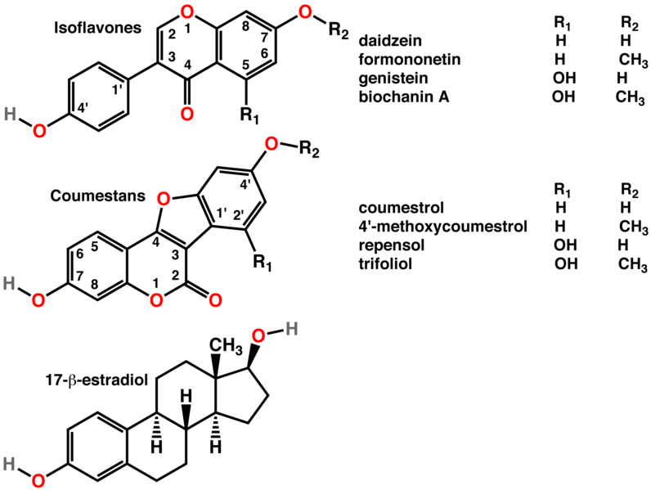
Polyphenols include phytoestrogens (top and middle), effective mimics of animal estrogen (bottom).
- A glycoside is a molecule in which carbohydrate is bound by a glycosidic bond to a non-carbohydrate moiety containing a hydroxyl group. The sugar most commonly found in glycosides is glucose. Among diverse group of glycosides three are most important. These are saponins, cardiac glycosides and cyanogenic glycosides.
Anthraquinone glycosides are found in the laxatives senna, rhubarb and Aloe.
The cardiac glycosides are powerful drugs from plants including foxglove and lily of the valley. They include digoxin and digitoxin which support the beating of the heart, and act as diuretics.
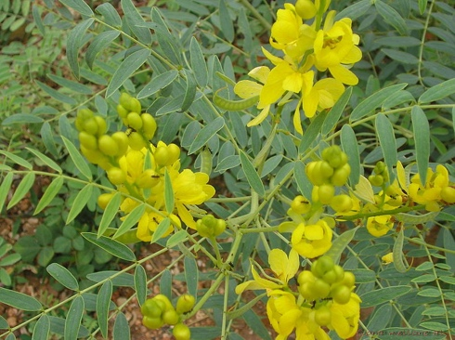
Senna alexandrina, containing anthraquinone glycosides, has been used as a laxative for millennia.
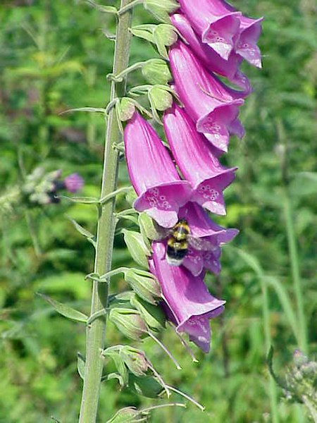
The foxglove, Digitalis purpurea, contains digoxin, a cardiac glycoside. The plant was used to treat heart conditions long before the glycoside was identified.^{[15][16]}
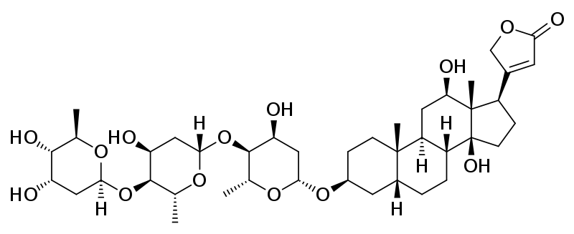
Digoxin is used to treat atrial fibrillation, atrial flutter and sometimes heart failure.
- Alkaloids: are a diverse group of nitrogen containing basic compounds. They are typically derived from plant sources and contain one or more nitrogen atoms. Chemically they are very heterogeneous. Based on chemical structures, they may be classified into two broad categories:
  - Non heterocyclic or atypical alkaloids, for example hordenine or N-methyltyramine, colchicine, and taxol
  - Heterocyclic or typical alkaloids, for example quinine, caffeine, and nicotine
Among the secondary metabolites there are several groups of substances which have the most pronounced effects on organism. These compounds are called biologically active substances. Alkaloids are bitter-tasting chemicals, very widespread in nature, and often toxic. There are several classes with different modes of action as drugs, both recreational and pharmaceutical. Medicines of different classes include atropine, scopolamine, and hyoscyamine (all from nightshade), the traditional medicine berberine (from plants such as Berberis and Mahonia),caffeine (Coffea), cocaine (Coca), ephedrine (Ephedra), morphine(opium poppy), nicotine (tobacco), reserpine (Rauwolfia serpentina), quinidine and quinine(Cinchona), vincamine (Vinca minor), and vincristine (Catharanthus roseus)
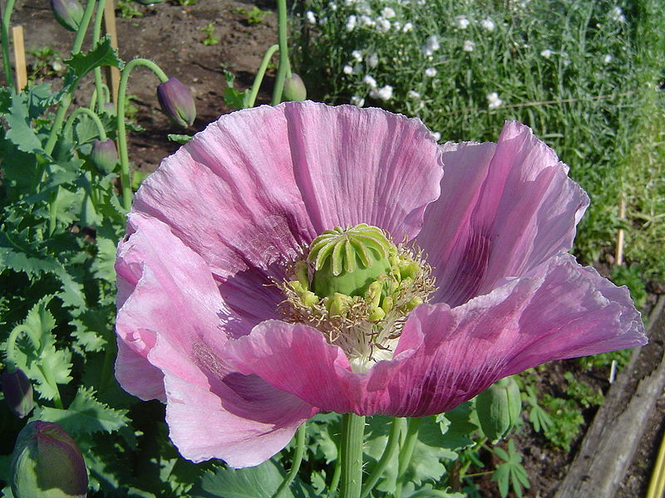
The opium poppy Papaver somniferum is the source of the alkaloids morphine and codeine.^{[5]}
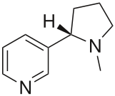
The alkaloid nicotine from tobacco binds directly to the body's Nicotinic acetylcholine receptors, accounting for its pharmacological effects.
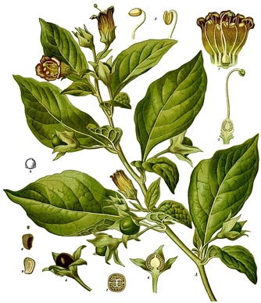
Deadly nightshade, Atropa belladonna, yields tropane alkaloids including atropine, scopolamine and hyoscyamine.

Biosynthezis of the secondary metabolites
The biosynthetic pathways leading to the major classes of natural products are described below.
- Photosynthesis or gluconeogenesis → monosaccharides → polysaccharides (cellulose, chitin, glycogen etc.)
- Acetate pathway → fatty acids and polyketides
- Shikimate pathway → aromatic amino acids and phenylpropanoids
- Mevalonate pathway and methyletrythritol phosphate pathway → terpenoids and steroids
- Amino acids → alkaloids

Isolation of plant secondary metabolites
A typical protocol to isolate a pure chemical agent from natural origin is bioassay-guided fractionation, meaning step-by-step separation of extracted components based on differences in their physicochemical properties, and assessing the biological activity, followed by next round of separation and assaying. Typically, such work is initiated after a given crude drug formulation (typically prepared by solvent extraction of the natural material) is deemed "active" in a particular in vitro assay. If the end-goal of the work at hand is to identify which one(s) of the scores or hundreds of compounds are responsible for the observed in vitro activity, the path to that end is fairly straightforward:
1. fractionate the crude extract, e.g. by solvent partitioning or chromatography.
2. test the fractions thereby generated with in vitro assay.
3. repeat steps 1 and 2 until pure, active compounds are obtained.
4. determine structure(s) of active compound(s), typically by using spectroscopic methods.
In vitro activity does not necessarily translate to activity in humans or other living systems. The most common means for fractionation are solvent-solvent partitioning and chromatographic techniques such as high-performance liquid chromatography (HPLC), medium-pressure liquid chromatography, "flash" chromatography, open-column chromatography, vacuum-liquid chromatography (VLC), thin-layer chromatography (TLC), with each technique being most appropriate for a given amount of starting material. Countercurrent chromatography (CCC) is particularly well-suited for bioassay-guided fractionation because, as an all-liquid separation technique, concern about irreversible loss or denaturation of active sample components is minimized. After isolation of a pure substance, the task of elucidating its chemical structure can be addressed. For this purpose, the most powerful methodologies available are nuclear magnetic resonance spectroscopy (NMR) and mass spectroscopy (MS). In the case of drug discovery efforts, structure elucidation of all components that are active in vitro is typically the end goal. In the case of phytotherapy research, the investigator may use in vitro BAGF as a tool to identify pharmacologically interesting or important components of the crude drug. The work does not stop after structural identification of in vitro actives, however. The task of "dissecting and reassembling" the crude drug one active component at a time, in order to achieve a mechanistic understanding of how it works in phytotherapy, is quite daunting. This is because it is simply too difficult, from cost, time, regulatory, and even scientific perspectives, to study experimental fractions of the crude drug in humans. In vitro assays are therefore used to identify chemical components of the crude drug that may rationally be expected to have a given pharmacological effect in humans, and to provide a rational basis for standardization of a crude drug formulation to be tested in [and sold/marketed to] humans.

Therapeutic significance of plant secondary metabolites
Secondary metabolites are organic compound produced and found in all plant tissues to drive metabolic activities, as well as providing self-defense against herbivore and any form of environmental toxicity. Plant is a well-known source of medicinal product for both traditional and modern medicines for the treatment and management of human illnesses. The usage of the plant in this regard is attributed to the presence of secondary metabolites. Apart from the fact that they are widely used in medicine, they are also employed industrially in the production and manufacturing of dyes, drugs, polymers, waxes, glues, fibers, antibiotics, herbicides, insecticides, cosmetics, etc.. In general, secondary metabolites found in plants can be categorized into three major groups including terpenes (cardiac glycosides, carotenoids, and sterols), phenolics (flavonoids and nonflavonoids), and nitrogen-based compounds (alkaloids and glucosinolates).
Terpenes are the largest and highly diversified class of secondary metabolites derived as a result of polymerization of isoprenoid unit of five carbon compounds. Based on the five carbon compound used as its building block, it can be subdivided into monoterpenes, sesquiterpenes, diterpenes, triterpenes, tetraterpenes, polyterpenes, and steroids whose precursor is triterpenes. The therapeutic significance of terpenoids from different plants has been reported, e.g., terpenes from eucalyptus oil is known for its antidiabetic property, ursolic acid from Rosmarinus officinalis and β-sesquiphellandrene from Piper guineense are known to be psychoprotective. Antibacterial and antifungal potential of terpenoids derived from Pilgerodendron uviferum, Picea abies and other plant sources have also been reported. Furthermore, a steroidal terpenoids called glycyrrhizic acid elicited anti-inflammatory activity.
The phenolics are secondary metabolites that are produced in the shikimic acid pathway of plants involving pentose phosphate through phenylpropanoid metabolization of at least one aromatic ring of hydrocarbon attached to one or more hydroxyl groups. Phenolics are generally categorized into two based on their structure, namely, flavonoids and nonflavonoids. Structurally, flavonoids are derived from two aromatic rings linked to a bridge consisting of three carbons (C₆▬C₃▬C₆) and are sub-divided into six main categories, including flavonols, flavones, flavanones, flavan-3-ols, isoflavones, and anthocyanins. However, the nonflavonoids are subdivided into five main categories, including hydroxybenzoates, hydroxycinnamates, lignans, and stilbenes. Compellingly, wide arrays of pharmacological potentials, such as antidiabetic, antioxidant, antiviral, antimicrobial, anticancer, and anti-inflammatory, have been credited to plant-based phenolic compounds. For example, cyanidin 3-sambubioside and 5-caffeoyl quinic acid derived from the fruit of Viburnum dilatatum Thumb. had been found to elicit significant antioxidant and radical scavenging activities while also inhibiting the syndrome-linked complications of postprandial hyperglycemia. Furthermore, plant-based phenolic acids such as garcinone E, kaempferol, resveratrol, syringaresinol, and quercetin are known to be potent anticancer agents. The anti-inflammatory, antiviral, and antibacterial potential of phenolics in the management of skin disorder have also been reported.
Alkaloids are structurally diversified secondary metabolites derived from nitrogen-based amino acid with nitrogen atom in the heterocyclic ring. Based on the nature of their heterocyclic and building block, alkaloids are classified into different subgroups such as indole, tropane, piperidine, purine, imidazole, pyrrolizidine, pyrrolidine, quinolizidine, and isoquinoline alkaloids. Noteworthy, therapeutic effects have been credited to a wide range of alkaloids from plants. Typical examples from alkaloids are Callistemon citrinus and Vernonia adoensis reported to elicit antibacterial effects on Staphylococcus aureus and Pseudomonas aeruginosa. Additionally, alkaloids originating from Aerva lanata roots were able to mitigate postprandial hyperglycemia in diabetic rats. The in vitro antioxidant activity of Phoebe declinata leaves extract has also been attributed to its alkaloid. It was found to inhibit 2,2-diphenyl-1-picrylhydrazyl (DPPH) radical while consequently reducing ferric chloride to ferrous. Furthermore, plant-based alkaloidal compounds such as reserpiline, α-yohimbine, methylaplysinopsin, isoquinoline, physostigmine, and pilocarpine are good psychoprotective agents.

